TOPIC/TITLE

DOM : Document Object Model

Keywords/Questions  Definition  How to visualise  Query selector  Properties  Methods | Notes :
 | It basically catalog the web page into individual objects that we can select and manipulate
 | Browser turn your data into a tree structure with a whole bunch of objects that you can select and manipulate.
 | 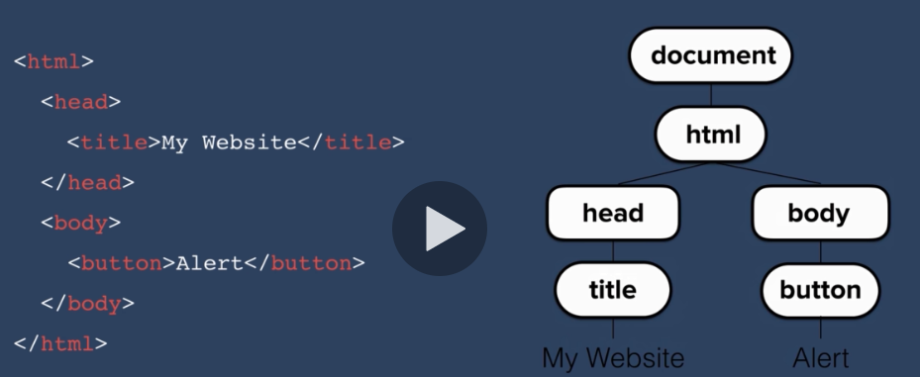
 | In the chrome console :
 | Document; => you can see the entire HTML file
 | Document.firstElementChild;
 | Document.firstElementChild.firstElementChild;
 | Document.firstElementChild.lastElementChild;
 | We can manipulate this elements wiith JS
 | If document.firstElementChild.lastElementChild.firstElementChild; refers to <h1>Hello</h1>
 | Then I can record it using a var like this
 | Var heading = document.firstElementChild.lastElementChild.firstElementChild;
 | Heading.innerHTML = “Good Bye”
 | Looks inside the entire document for the object that as the selector of “input”
 | Document.querySelector(input).click();
 | Click : does simulate a mouse click
 | An object in our dom can have properties and methods
 | Properties describes something about the object
 | Methods : what the object can do
 | 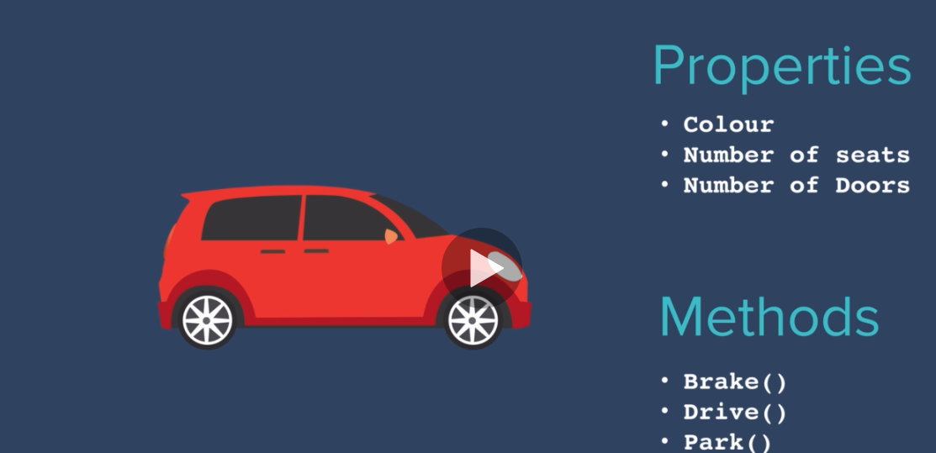
We ca use JS to manipulate our object using the dot notation
car.colour; //red => to get the value of the property
- This call a getter
With properties we can also set it :
Car.numbersOfDoor = 0;
- It is called setting a property
Difference we use = to set a property

Car.drive();
In that case ou car will do something
Difference between method and object is that a method is something that an object can do, it has to be associated with an oject.

